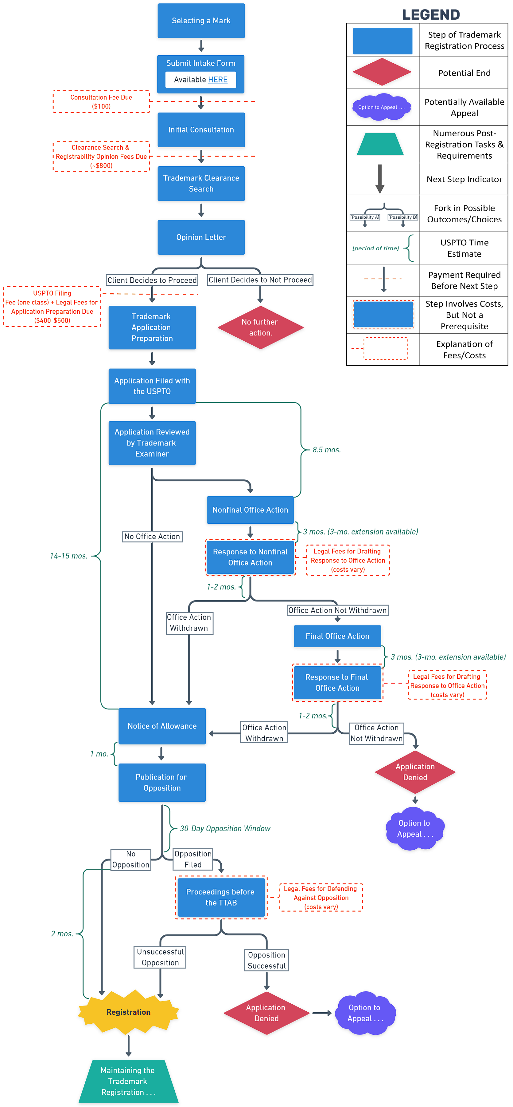



**TRADEMARK REGISTRATION APPLICATION PROCESS**



1. **Selecting a Mark**: The first step is to choose a mark that you want to register. This could be a word, phrase, symbol, or design that identifies and distinguishes the source of your goods or services from others. Trademarks are typically categorized as fanciful, arbitrary, suggestive, descriptive, or generic. Fanciful marks are invented words with no dictionary or other known meaning. Arbitrary marks are existing words that have no connection or relevance to the goods or services being sold. Suggestive marks suggest a characteristic of the goods or services but require some imagination to connect the mark with the goods or services. Descriptive marks describe a characteristic or quality of the goods or services. Generic terms are common words or terms that are the accepted and recognized description of a class of goods or services. It's best to select fanciful or arbitrary marks because they are inherently distinctive and easier to protect.
2. **Intake Form**: The first formal step to launching the registration process is filling out the trademark intake form, which allows the attorney to conduct a preliminary assessment of your mark and gather all required information.
3. **Initial Consultation with Attorney**: You would typically consult with a law firm or a trademark attorney to discuss your mark, your business, and your goals for the trademark. The attorney can provide advice on whether your mark is likely to be registrable and how to proceed. Please note that while a $100 consultation fee is charged when scheduling the consultation, if the client wishes to proceed with the trademark registration process, the $100 is credited towards those subsequent costs.
4. **Trademark Search (Clearance Search)**: The law firm conducts a comprehensive search of existing trademarks to check if your chosen mark or a similar one is already registered or applied for by someone else. This is known as a clearance search. Because the clearance search and the opinion letter described in the following step involve both flat fees and a significant investment of time and effort, the fees for the clearance search and opinion letter are to be paid prior to the commencement of this step. While the cost of this will varies case by case, it typically is around $800 for an application to register one mark in one class of goods or services.
5. **Opinion Letter**: Based on the results of the clearance search, the law firm will provide an opinion letter. This letter will detail the likelihood of successful registration, potential conflicts, and any other issues that might affect the registrability of your mark. If the opinion letter reveals significant hurdles to registration, it is not uncommon for the trademark registration applicant to make changes to the mark and/or goods or services claimed, pursue an entirely new idea, or decide not to continue with the trademark registration application process altogether.
6. **Trademark Application Preparation**: If the opinion letter is favorable, the next step is to prepare the trademark application. This includes providing information about the mark, the goods or services it will be used for, and the applicant's information. Depending on the type of application used (which is determined by the goods and services sought to be claimed in the application), the USPTO filing fees and legal fees for preparing the application typically range between $400-$500 for an application to register one mark in a single class of goods or services. This payment must be made prior to the commencement of this step.
7. **Filing the Application with the U.S. Patent and Trademark Office ("USPTO")**: The application is then filed with the USPTO. The filing date is important as it establishes who filed first in case of disputes. Currently, absent any Office Actions (see below), the average time between filing the application and receiving a Notice of Allowance (see step 14) is about 14-15 months.
8. **Review by the USPTO**: The USPTO assigns an examining attorney to review the application. This review includes checking for compliance with formalities and substantive issues like likelihood of confusion with existing marks.
9. **Non-Final Office Actions**: If the examining attorney identifies any issues with the application, they will issue a non-final Office Action. This is a document that explains the issues and gives the applicant a chance to respond.
10. **Response to Non-Final Office Actions**: The applicant (or their attorney) must respond to any non-final Office Actions within a specified time frame. The response should address the issues raised by the examining attorney.
11. **Final Office Actions**: If the examining attorney is not satisfied with the response, or if new issues arise, they may issue a final Office Action. This provides a final opportunity for the applicant to address the issues.
12. **Response to Final Office Actions**: The applicant (or their attorney) must respond to the final Office Action. If the issues are not satisfactorily resolved, the application may be refused.
13. **Appeal of Refusal**: If the application is refused, the applicant can appeal the decision to the Trademark Trial and Appeal Board ("TTAB"). This must be done within six months of the final refusal. The details of an appeal, however, are outside the scope of this overview.
14. **Notice of Allowance**: If the examining attorney is satisfied with the response and all issues have been resolved, a Notice of Allowance is issued. This indicates that the mark has been allowed for publication.
15. **Publication for Opposition**: If the examining attorney approves the application, it is published in the Official Gazette. This gives third parties a chance to oppose the registration if they believe it would infringe on their rights.
16. **Opposition Period**: There is a 30-day period during which third parties can file an opposition. If an opposition is filed, proceedings are held before the TTAB. While it is worth noting that opposition proceedings can be long and costly, a full discussion of these proceedings is outside the scope of this overview.
17. **Registration**: If there is no opposition, or if an opposition is unsuccessful, the mark is registered within two months. Once registered, the owner of the mark has exclusive rights to use the mark nationwide in connection with the goods and/or services listed in the registration.
18. **Maintaining the Trademark**: After registration, there are maintenance documents that must be filed at regular intervals to keep the registration alive. While noted here, trademark registration maintenance is beyond the scope of this overview.